**Automation project instructions**

This automation framework project is written entirely in Java and made using Eclipse IDE.

The BDD is written in Cucumber.

The project structure looks like this

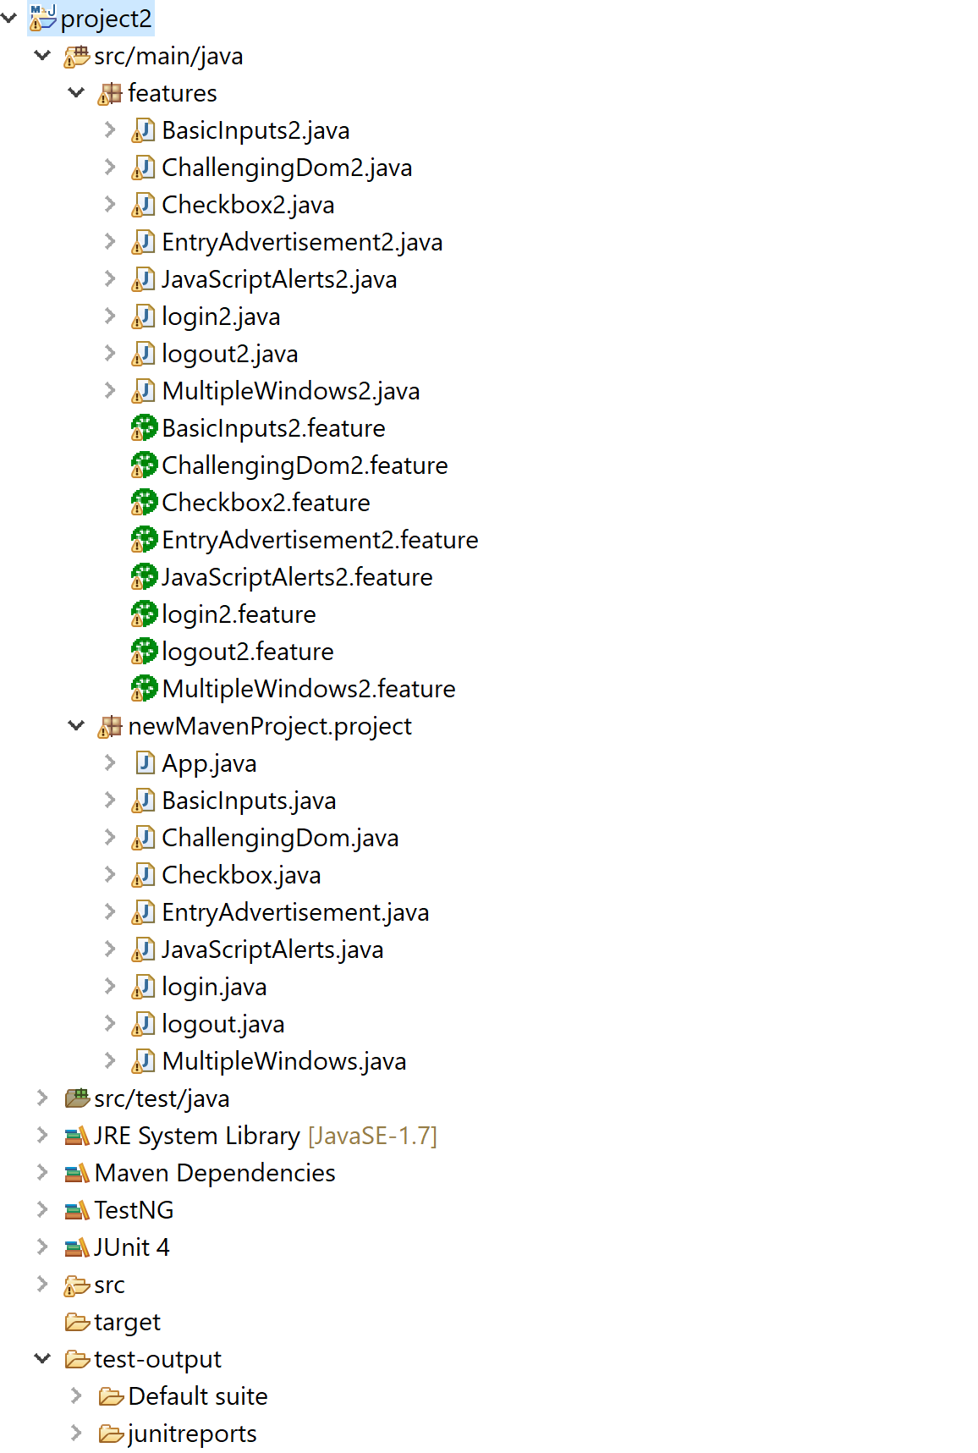

There are in total automation scenarios, these are

Login

Logout

Basic Inputs

Challenging DOM

Checkbox

Entry Advertisement

Javascript Alerts

Multiple Windows

The class logics are in individual .java class files

The cucumber scenarios are in individual .feature files under the features package.

There are two packages here

- features

- newMavenProject

**This entire project is written in two different ways**

**1st way** - It is written is as an official Java framework with classes (i.e. step definition files) which links to each feature files, this is all under the under the features package.

**2nd way** - The second way the project is written is directly without feature files but more in a procedural approach, in other words just individual test classes that can be executed one after the other as TestNG. This is under the under the newMavenProject package.

**The project should be run using the second way as I have not been able to link the cucumber feature files with the .java step definition files due to IDE issues causing unknown errors, therefore I had another package as newMavenProject with only the automation logic included which would do the exact same thing but without the cucumber feature file.**

**However I have still included the first way to show that the framework can be implemented in both ways.**

|  |  |
| --- | --- |
| **The java files (step definitions) are** | **Its corresponding cucumber feature files are** |
| BasicInputs2.java | BasicInputs2.feature |
| ChallengingDom2.java | ChallengingDom2. feature |
| Checkbox2.java | Checkbox2.feature |
| EntryAdvertisement2.java | EntryAdvertisement2.feature |
| JavaScriptAlerts2.java | JavaScriptAlerts2.feature |
| login2.java | login2.feature |
| logout2.java | logout2.feature |
| MultipleWindows2.java | MultipleWindows2.feature |

**Instructions about how to use the project**

* Step 1 Ide Ecplise is needed preferably
* Step 2 Use the **pom.xml** to download all the dependencies like .jar files of the project otherwise it shall not work.

Either open the pom file in the IDE and press save

Or (if you are using Eclipse IDE) right click on the pom file - maven and click update project

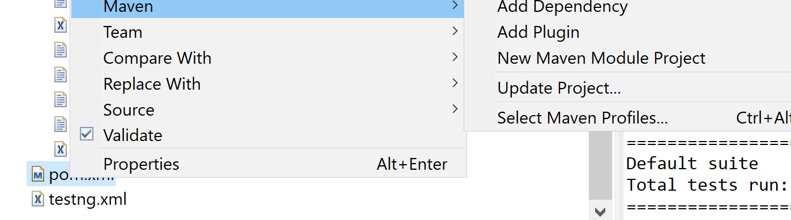

* Step 3 Once all dependencies are downloaded in the project a webdriver needs to be used to open Google Chrome browser.

This is in the folder called **chromedriver_win32.zip**

Extract this .zip file in e.g. desktop

* Step 4 Then in every of these class files

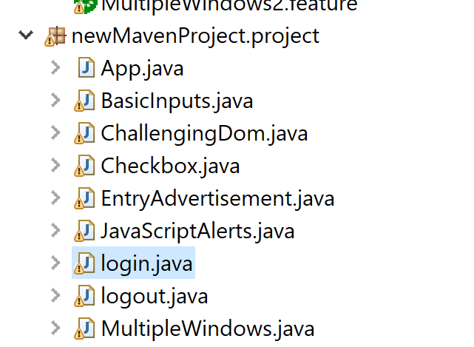

the chrome driver’s location in mentioned e.g.

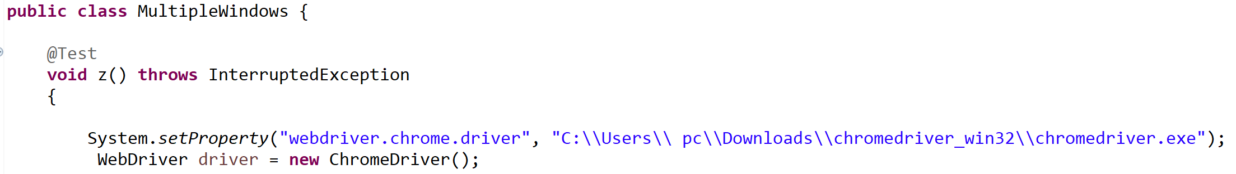

On each of these classes this path needs to be changed to the location where the extracted chromedriver is located in your machine.

* Step 5 please ensure that you can run the .java files as a TestNG test
* Step 6 under the package newMavenProject you can either execute each of the .java files individually one after the other as TestNG, or you can right click on the package and run all

of those as TestNG Test.

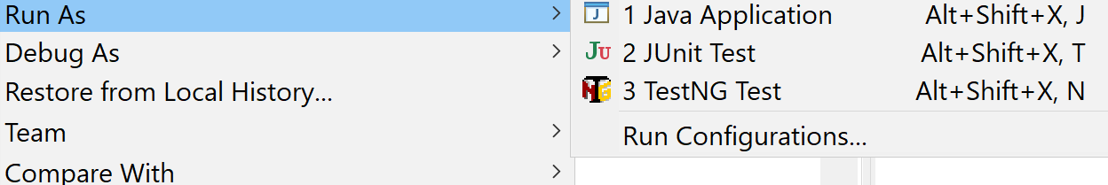

This shall produce a report in html format called “emailable-report.html” under the folder test-output

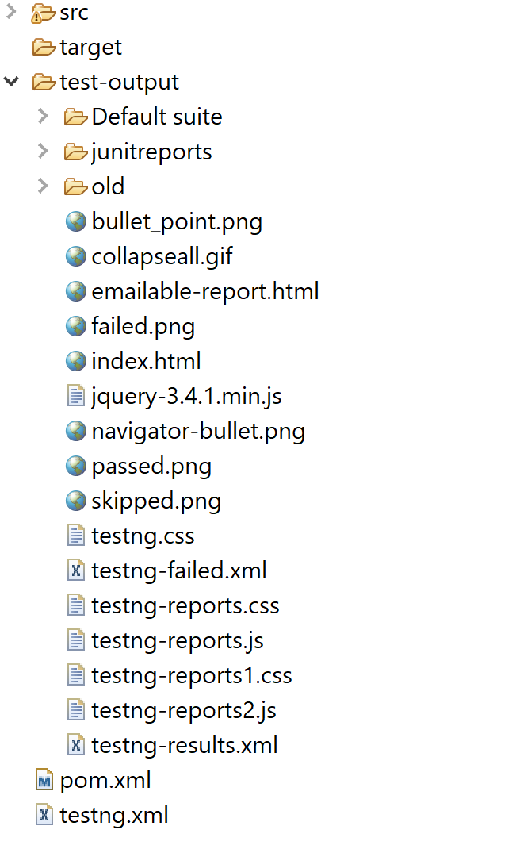

If this file is opened after tests have been executed this shall show the list of all the classes that have been executed and which have passed and how many milliseconds it took for execution.

An example of an execution session was

